Practical- 7: Design of Experiment
Name: Manthan Daraji
PRN: 2020033800148223

QUESTION-1

- An accounting firm, prior to introducing widespread training in statistical sampling for auditing, tested three methods:
- Study at home with programmed training materials,
- Training sessions at local offices conducted by local staff, and
- Training session in Chicago conducted by a national staff.

Thirty officers were grouped into ten blocks of three, according to time elapsed since college graduation, and the auditors in each block were randomly assigned to the three training methods.
At the end of the training, each auditor was asked to analyze a complex case involving statistical applications; a proficiency measure based on this analysis was obtained for each auditor.
The results were (block 1 consists of auditors who graduated most recently, block 10 consists of those graduated most distantly):
Block | 1 | 2 | 3
1 | 73 | 81 | 92
2 | 76 | 78 | 89
3 | 75 | 76 | 87
4 | 74 | 77 | 90
5 | 76 | 71 | 88
6 | 73 | 75 | 86
7 | 68 | 72 | 88
8 | 64 | 74 | 82
9 | 65 | 73 | 81
10 | 62 | 69 | 78
Identify the design analyze it at 5% level of significance. write appropriate interpretation.

- MINITAB OUTPUT

General Linear Model: Score versus Treatments, Blocks

Method
Factor coding | (-1, 0, +1)
Factor Information
Factor | Type | Levels | Values
Treatments | Fixed | 3 | 1, 2, 3
Blocks | Fixed | 10 | 1, 2, 3, 4, 5, 6, 7, 8, 9, 10
Hypothesis:

H01: All Treatments are equally Effective
vs
H11: All Treatments are not equally effective

H02: All Blocks are equally effective
vs
H22: All Blocks are not equally effective

Analysis of Variance
Source | DF | Adj SS | Adj MS | F-Value | P-Value
Treatments | 2 | 1295.0 | 647.500 | 103.75 | 0.000
Blocks | 9 | 433.4 | 48.152 | 7.72 | 0.000
Error | 18 | 112.3 | 6.241
Total | 29 | 1840.7

Model Summary
S | R-sq | R-sq(adj) | R-sq(pred)
2.49815 | 93.90% | 90.17% | 83.05%

Coefficients
Term | Coef | SE Coef | T-Value | P-Value | VIF
Constant | 77.100 | 0.456 | 169.04 | 0.000
Treatments
1 | -6.500 | 0.645 | -10.08 | 0.000 | 1.33
2 | -2.500 | 0.645 | -3.88 | 0.001 | 1.33
Blocks
1 | 4.90 | 1.37 | 3.58 | 0.002 | 1.80
2 | 3.90 | 1.37 | 2.85 | 0.011 | 1.80
3 | 2.23 | 1.37 | 1.63 | 0.120 | 1.80
4 | 3.23 | 1.37 | 2.36 | 0.030 | 1.80
5 | 1.23 | 1.37 | 0.90 | 0.379 | 1.80
6 | 0.90 | 1.37 | 0.66 | 0.519 | 1.80
7 | -1.10 | 1.37 | -0.80 | 0.432 | 1.80
8 | -3.77 | 1.37 | -2.75 | 0.013 | 1.80
9 | -4.10 | 1.37 | -3.00 | 0.008 | 1.80

Regression Equation
Score | = | 77.100 - 6.500 Treatments_1 - 2.500 Treatments_2 + 9.000 Treatments_3 + 4.90 Blocks_1  + 3.90 Blocks_2 + 2.23 Blocks_3 + 3.23 Blocks_4 + 1.23 Blocks_5 + 0.90 Blocks_6  - 1.10 Blocks_7 - 3.77 Blocks_8 - 4.10 Blocks_9 - 7.43 Blocks_10

Fits and Diagnostics for Unusual Observations
Obs | Score | Fit | Resid | Std Resid
13 | 76.00 | 71.83 | 4.17 | 2.15 | R
14 | 71.00 | 75.83 | -4.83 | -2.50 | R
R Large residual

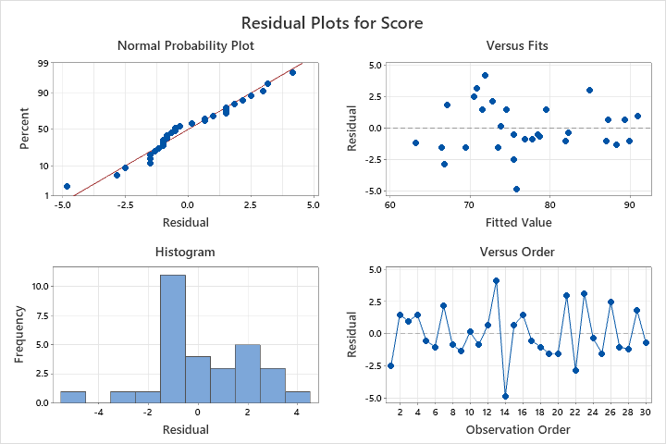

Conclusion:

- Form ANOVA table, For treatments P-value (0.000) < 0.05 (LEVEL OF SIGNIFICANCE). So, we reject null hypothesis, and we can say that all treatments are not equally effective.

- Form ANOVA table, For blocks P-value (0.000) < 0.05 (LEVEL OF SIGNIFICANCE). So, we reject null hypothesis, and we can say that all blocks are not equally effective.

QUESTION-2

- The yield of a particular chemical process is being studied. Two important variables are thought to be pressure and temperature. Two levels of each factor are selected and run for three replicates each. The data on yield are as follows:
Temperature (ºC) | Pressure (psi)
Temperature (ºC) | 100 | 200
150 | 90.4 | 90.7
150 | 90.2 | 90.6
150 | 90.1 | 90.5
250 | 90.3 | 90.6
250 | 90.5 | 90.8
250 | 90.7 | 90.9
Here y = yield and the factors are temperature (x₁) and pressure (x₂). Analyze the design at 5% level of significance. In this problem, the engineers want to answer the following questions:
- What effects do x1 and x2 have on y?
- What effects do the 250 ºC of x1 and 100 psi of x2 have on y?

- MINITAB OUTPUT

Multilevel Factorial Design

Design Summary
Factors: | 2 | Replicates: | 3
Base runs: | 4 | Total runs: | 12
Base blocks: | 1 | Total blocks: | 1
Number of levels: 2, 2
General Factorial Regression: Yield versus Temp, Press

Factor Information
Factor | Levels | Values
Temp | 2 | 150, 250
Press | 2 | 100, 200

Hypothesis:

H₀₁: All row treatment (levels of temperature) is equal.
H₀₂: All column treatment (level of pressure) is equal.
H₀₃: All row and column treatment interaction effects are equal.

Analysis of Variance
Source | DF | Adj SS | Adj MS | F-Value | P-Value
Model | 3 | 0.449167 | 0.149722 | 6.20 | 0.018
Linear | 2 | 0.441667 | 0.220833 | 9.14 | 0.009
Temp | 1 | 0.140833 | 0.140833 | 5.83 | 0.042
Press | 1 | 0.300833 | 0.300833 | 12.45 | 0.008
2-Way Interactions | 1 | 0.007500 | 0.007500 | 0.31 | 0.593
Temp*Press | 1 | 0.007500 | 0.007500 | 0.31 | 0.593
Error | 8 | 0.193333 | 0.024167
Total | 11 | 0.642500

Model Summary
S | R-sq | R-sq(adj) | R-sq(pred)
0.155456 | 69.91% | 58.63% | 32.30%

Coefficients
Term | Coef | SE Coef | T-Value | P-Value | VIF
Constant | 90.5250 | 0.0449 | 2017.21 | 0.000
Temp
150 | -0.1083 | 0.0449 | -2.41 | 0.042 | 1.00
Press
100 | -0.1583 | 0.0449 | -3.53 | 0.008 | 1.00
Temp*Press
150 100 | -0.0250 | 0.0449 | -0.56 | 0.593 | 1.00

Regression Equation
Yield | = | 90.5250 - 0.1083 Temp_150 + 0.1083 Temp_250 - 0.1583 Press_100 + 0.1583 Press_200  - 0.0250 Temp*Press_150 100 + 0.0250 Temp*Press_150 200 + 0.0250 Temp*Press_250 100  - 0.0250 Temp*Press_250 200
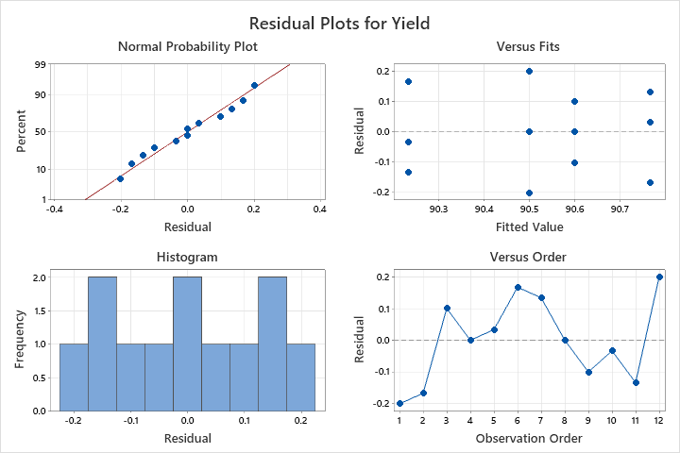
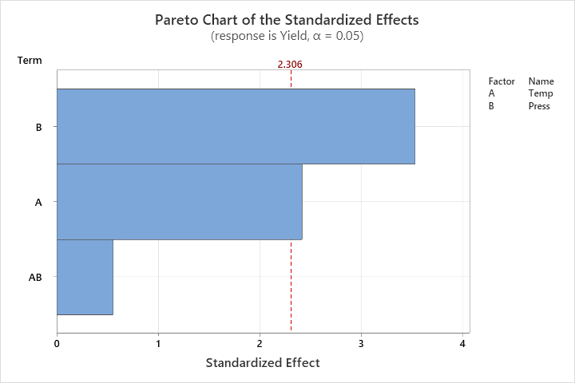

Conclusion:

- From the ANOVA table, the p-value for Temperature and Pressure is smaller than 5% level of significance, The hypothesis H01 and H02 rejected. So, we can say that all row treatments for level of temperature and all column treatments for level of pressure are not equally effective.

- From the ANOVA table, the p-value for interaction between Temperature and Pressure is Greater than 5% level of significance, The hypothesis H03 do not rejected. So, we can say that all row and column interaction effects are equally effective.
QUESTION-3
- Firing time of explosive switches depends on three factors:
- The metal used
- The amount of primary initiator and
- The packing pressure of the explosive

Two levels of each are considered for manufacturing the switches. They include two metal compositions for factor A, say a₀ (=soft) and a₁ (=hard); two specific number of initiators for factor B, say b₀ (=10 mg) and b₁ (=15 mg); and two packing pressure for factor C, say c₀ (=12000 psi) and c₁ (=20000 psi). For each of these eight combinations, two switches are manufactured and tested.
 | Factor A
 | a₀ (=soft) |  | a₁ (=hard)
 | Factor B |  | Factor B
Factor C | b₀ (=10 mg) | b₁ (=15 mg) | b₀ (=10 mg) | b₁ (=15 mg)
c₀ (=12000 psi) | 40 | 29 | 32 | 16
c₀ (=12000 psi) | 39 | 34 | 30 | 12
c₁ (=20000 psi) | 35 | 27 | 25 | 11
c₁ (=20000 psi) | 30 | 28 | 26

- MINITAB OUTPUT

Multilevel Factorial Design
Design Summary
Factors: | 3 | Replicates: | 2
Base runs: | 8 | Total runs: | 16
Base blocks: | 1 | Total blocks: | 1
Number of levels: 2, 2, 2
Factor Information
Factor | Levels | Values
Factor-A | 2 | soft, hard
Factor-B | 2 | 10mg, 15mg
Factor-C | 2 | 12000psi, 20000psi
Hypothesis:
H₀₁: level of Factor A is not significant.
H₀₂: level of Factor B is not significant.
H₀₃: level of Factor C is not significant.
H₁₂₃: All row and column treatment interaction effects are not significant.
Analysis of Variance
Source | DF | Adj SS | Adj MS | F-Value | P-Value
Model | 7 | 1236.94 | 176.705 | 36.72 | 0.000
Linear | 3 | 1146.69 | 382.229 | 79.42 | 0.000
Factor-A | 1 | 588.06 | 588.062 | 122.19 | 0.000
Factor-B | 1 | 473.06 | 473.063 | 98.30 | 0.000
Factor-C | 1 | 85.56 | 85.563 | 17.78 | 0.003
2-Way Interactions | 3 | 90.19 | 30.063 | 6.25 | 0.017
Factor-A*Factor-B | 1 | 76.56 | 76.563 | 15.91 | 0.004
Factor-A*Factor-C | 1 | 3.06 | 3.063 | 0.64 | 0.448
Factor-B*Factor-C | 1 | 10.56 | 10.562 | 2.19 | 0.177
3-Way Interactions | 1 | 0.06 | 0.062 | 0.01 | 0.912
Factor-A*Factor-B*Factor-C | 1 | 0.06 | 0.062 | 0.01 | 0.912
Error | 8 | 38.50 | 4.813
Total | 15 | 1275.44

Model Summary
S | R-sq | R-sq(adj) | R-sq(pred)
2.19374 | 96.98% | 94.34% | 87.93%

Coefficients
Term | Coef | SE Coef | T-Value | P-Value | VIF
Constant | 26.688 | 0.548 | 48.66 | 0.000
Factor-A
soft | 6.063 | 0.548 | 11.05 | 0.000 | 1.00
Factor-B
10mg | 5.438 | 0.548 | 9.91 | 0.000 | 1.00
Factor-C
12000psi | 2.313 | 0.548 | 4.22 | 0.003 | 1.00
Factor-A*Factor-B
soft 10mg | -2.188 | 0.548 | -3.99 | 0.004 | 1.00
Factor-A*Factor-C
soft 12000psi | 0.438 | 0.548 | 0.80 | 0.448 | 1.00
Factor-B*Factor-C
10mg 12000psi | 0.812 | 0.548 | 1.48 | 0.177 | 1.00
Factor-A*Factor-B*Factor-C
soft 10mg 12000psi | -0.062 | 0.548 | -0.11 | 0.912 | 1.00
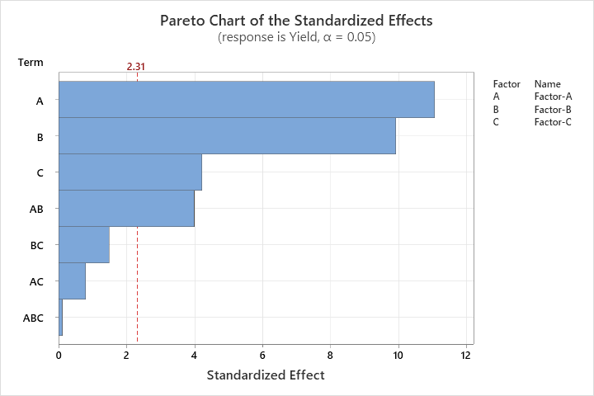
Regression Equation
Yield | = | 26.688 + 6.063 Factor-A_soft - 6.063 Factor-A_hard + 5.438 Factor-B_10mg  - 5.438 Factor-B_15mg + 2.313 Factor-C_12000psi - 2.313 Factor-C_20000psi  - 2.188 Factor-A*Factor-B_soft 10mg + 2.188 Factor-A*Factor-B_soft 15mg  + 2.188 Factor-A*Factor-B_hard 10mg - 2.188 Factor-A*Factor-B_hard 15mg  + 0.438 Factor-A*Factor-C_soft 12000psi - 0.438 Factor-A*Factor-C_soft 20000psi  - 0.438 Factor-A*Factor-C_hard 12000psi + 0.438 Factor-A*Factor-C_hard 20000psi  + 0.812 Factor-B*Factor-C_10mg 12000psi - 0.812 Factor-B*Factor-C_10mg 20000psi  - 0.812 Factor-B*Factor-C_15mg 12000psi + 0.812 Factor-B*Factor-C_15mg 20000psi  - 0.062 Factor-A*Factor-B*Factor-C_soft 10mg 12000psi  + 0.062 Factor-A*Factor-B*Factor-C_soft 10mg 20000psi  + 0.062 Factor-A*Factor-B*Factor-C_soft 15mg 12000psi  - 0.062 Factor-A*Factor-B*Factor-C_soft 15mg 20000psi  + 0.062 Factor-A*Factor-B*Factor-C_hard 10mg 12000psi  - 0.062 Factor-A*Factor-B*Factor-C_hard 10mg 20000psi  - 0.062 Factor-A*Factor-B*Factor-C_hard 15mg 12000psi  + 0.062 Factor-A*Factor-B*Factor-C_hard 15mg 20000psi

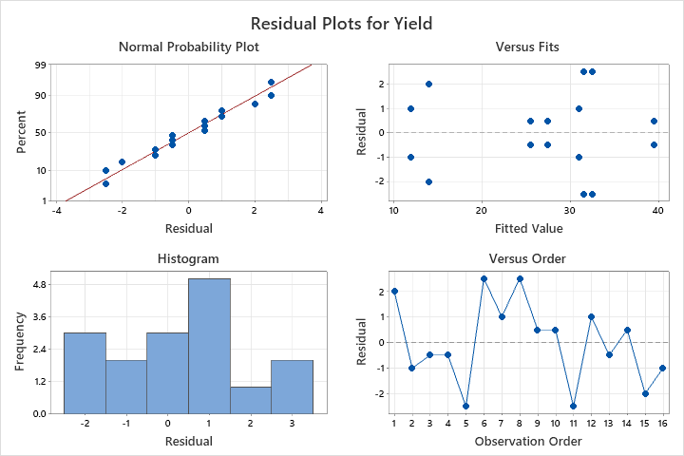

Conclusion:

- The residual analysis does not show any kind of unusual observations. The residuals are normal, and the run orders are also random.

- Form ANOVA TABLE, P-value of Main effects Factor-A, Factor-B, Factor-C are smaller than 5% level of significance. So, we reject the null hypothesis for all main treatment effects. And we can say that Level of Factor-A, Factor-B and Factor-C are significant.

- Form ANOVA TABLE, P-value of Two-way interaction effect between Factor-A and Factor-B is smaller than alpha (0.05). So, we can say that interaction effect Factor-A*Factor-B is significant.

- Form ANOVA TABLE, P-value of Two-way interaction effects between Factor-B*Factor-C & Factor-A*Factor-C and Three-way interaction effect Factor-A * Factor-B * Factor-C are Greater than alpha (0.05). So, we do not reject the null hypothesis and we can say that these interaction effects are not significant.

